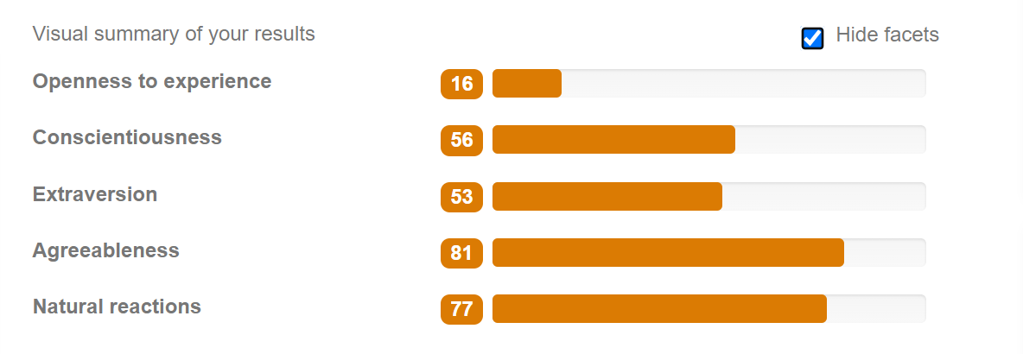

Examples;

**Openness to Experience:**

Will always prefer traditional cuisine rather than trying something new.

**Conscientiousness:**

I am always focused on my goals. Like in all my academic exams, even if I am prepared, I do get anxiety that I am not studying and wasting time.

**Extraversion:**

I enjoy being in the driver seat at most events. In my college farewell, no one asked me to do the arrangements but I myself jumped into it believing in myself that I could do better than others in terms of planning and execution.

**Agreeableness:**

I cannot say “no” to someone. Recently, a friend of mine called me and asked me to explain a topic to him. I was going to do an assignment which was due but I just couldn’t say no to him.

**Natural Reactions:**

I feel the behavior of a person. For me the actions speak more than the words. If someone is yelling at me (even for fun). It will make me upset or sad easily.